LAB#13
ABSTRACT DATA TYPES
OBJECTIVE:
Understanding and implementing abstract data types.
LAB TASK 01 :
CODE :
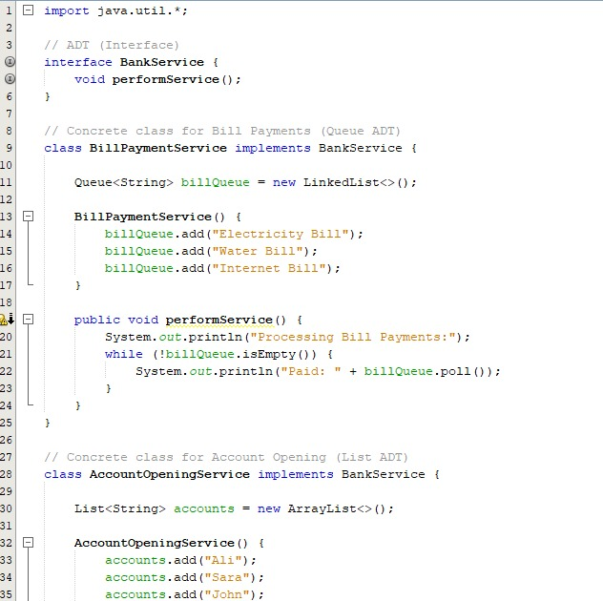
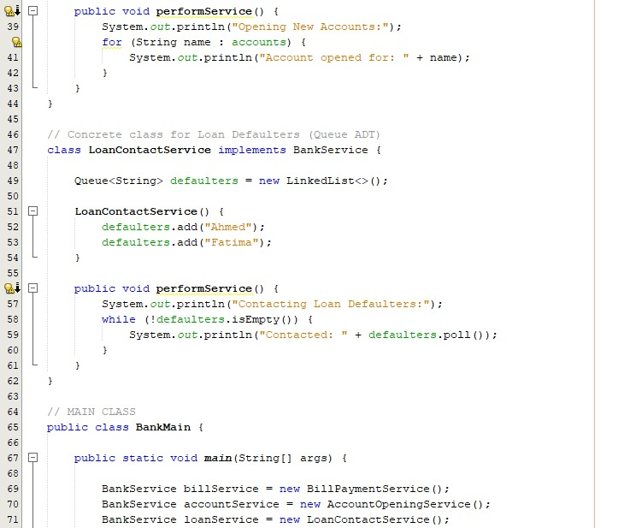
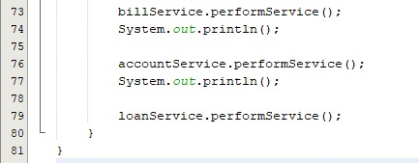

OUTPUT :
